|  |
| --- |
| *Report on Co-Curricular activities done as a part of*  **EXC-1138 - HEALTH THROUGH EXERCISE**  Submitted by  **R.HEMESH**  **22BCT0328**  To  **Dr. Vipin Singh**  Fall Semester, 2023-24 |

**Table of Activities**

|  |  |  |  |  |
| --- | --- | --- | --- | --- |
| **S. No** | **Events/Activities/Workshops**  **/Webinars** | **Date** | **Hours Spent** | **Page** |
| **1** | **Athletic Trifecta (Morning)** | **27/08/2023** | **04** | **02** |
| **2** | **Athletic Trifecta (Afternoon)** | **27/08/2023** | **03** | **02** |
| **3** | **Mental Health Matters (MHM)** | **14/10/2023** | **12** | **04** |
| **4** | **Virtual Session on Our Club's Mission and Activities** | **03/11/2023** | **02** | **06** |
| **5** | **Fitness Frenzy** | **13/11/2023** | **15** | **08** |
| **6** | **Offline Orientation** | **24/11/2023** | **02** | **10** |
| **7** | **Nutrition Nirvana** | **25/11/2023** | **18** | **12** |
| **8** | **Gym Jams** | **27/11/2023** | **14** | **13** |
| **9** | **Wellness Wisdom** | **30/11/2023** | **16** | **15** |
| **10** | **VITMUN Conference Opening Ceremony** | **20/04/2024** | **02** | **16** |
| **11** | **Studied a book & Understood the importance of Fitness:** | **10/03/2024** | **05** | **17** |
| **12** | **Report Making Time** | **23/04/2024** | **04** | **18** |
|  |  | **Total Hours** | **97** |  |

**Description of Events/ Activities**

1. **Athletic Trifecta**

**Event Description**

The "Athletic Trifecta" is an exciting fitness relay event that tests participants in Endurance, Strength, and Speed. Organized by SW Events, it guarantees a day full of teamwork, excitement, and competition. Originally scheduled for a different date, the event has been moved to 4:00 PM on **August 27, 2023.**

This relay has a unique twist: teams race against the clock to complete tasks. As each team member finishes their challenge, they tag the next teammate, and the team's time decreases. It becomes a race against both other teams and the clock itself.

At the event's conclusion, the top three teams with the best times are crowned champions and receive trophies and medals. The Athletic Trifecta offers participants a day of sweat, cheers, and team spirit. It challenges individuals physically while promoting teamwork and camaraderie. Whether you're a fitness enthusiast pushing your boundaries or simply looking for a fun way to stay active, the Athletic Trifecta has something for everyone.

**No. of Hours Spent:** 4 (Morning) + 3 (afternoon) = 7 hrs

**Screenshots:**

**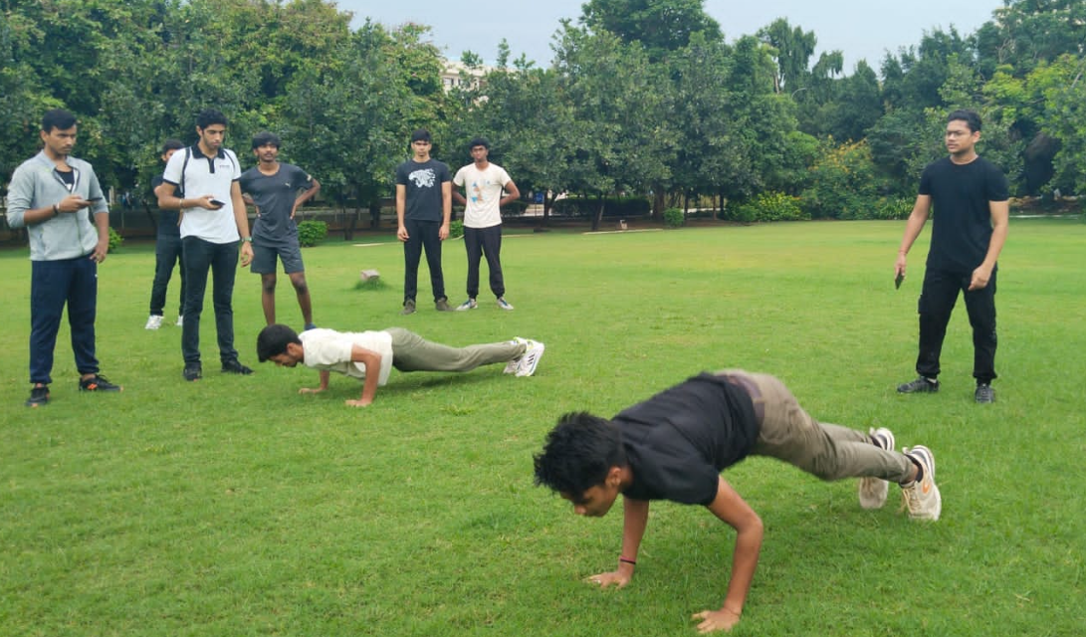** **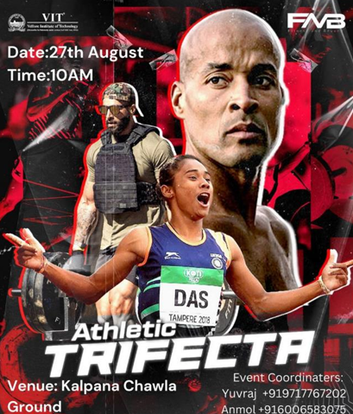**

**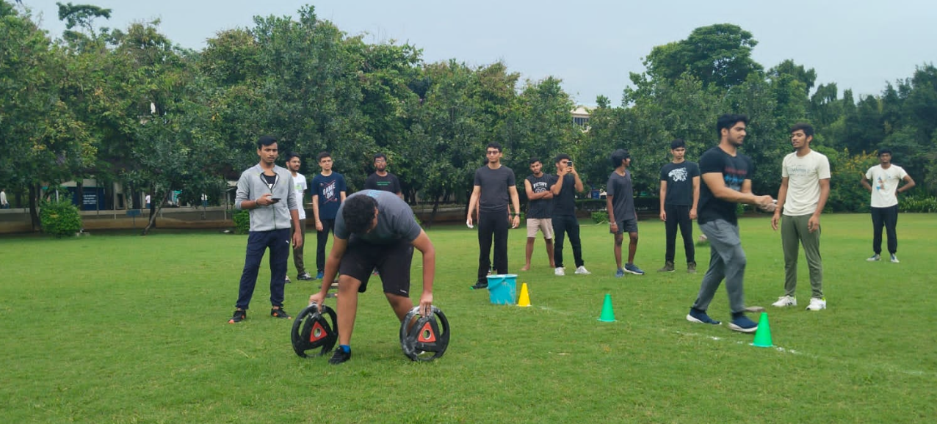**

**3.Mental Health Matters :**

The "Mental Health Matters" event is dedicated to highlighting the importance of mental well-being among university students. It serves as a supportive platform, encouraging open discussions, offering practical strategies, and providing expert insights to help students manage the challenges of academic life while prioritizing their emotional health. The event was scheduled for **October 14th.**

The speaker **Dr. Jetson Satya Gospel** stresses the significance of mental health as a top priority for university students, promoting awareness about the importance of balancing a healthy mind with academic pursuits.

The addresses the importance to provide a safe and inclusive environment for students to engage in open discussions about mental health, encouraging them to share their experiences, challenges, and coping mechanisms. This fosters a supportive community where students can learn from each other.

"Mental Health Matters" offers practical strategies and tools to help students effectively manage stress, anxiety, and other mental health concerns. Through workshops, seminars, and interactive sessions, students will learn actionable steps and resources to improve their mental well-being.

Target Audience: The event is tailored for university students from diverse disciplines and backgrounds.

Key Activities:

* Open Discussions: Panels and group discussions on various mental health topics.
* Workshops: Interactive sessions focusing on practical strategies for stress management and improving mental well-being.
* Expert Talks: Insightful presentations by mental health professionals and experts in the field.

**Conclusion:** "Mental Health Matters" promises to be a transformative experience for university students, offering a comprehensive approach to mental well-being. By emphasizing the importance of mental health, facilitating open discussions, providing practical strategies, and offering expert insights, the event aims to empower students with the knowledge and tools needed to prioritize their mental well-being and succeed academically and personally.

**No. of Hours Spent:** 4 hrs + 4 hrs (self study) + 3 hrs gym (daily activity) + 1hr (meditation) = 12 hours

**Screenshots:**

**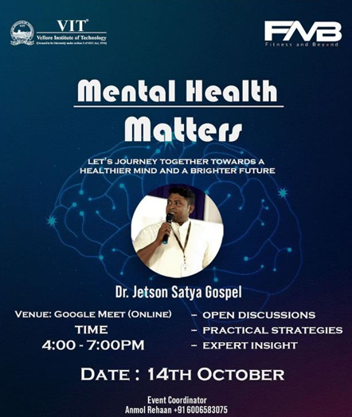**

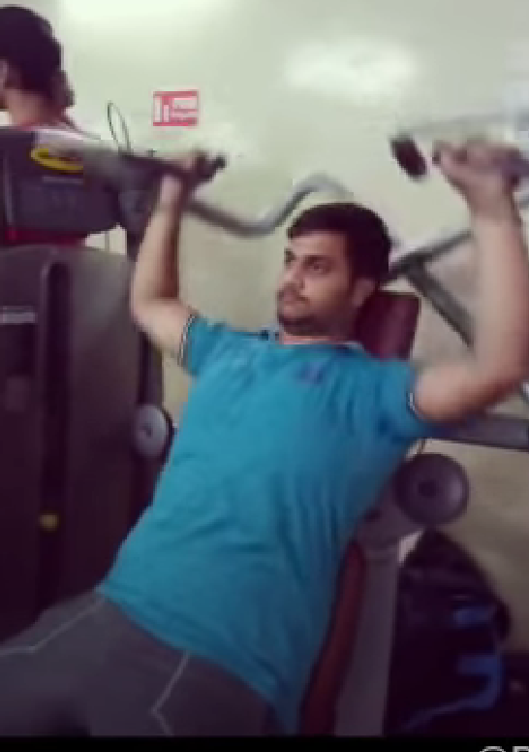**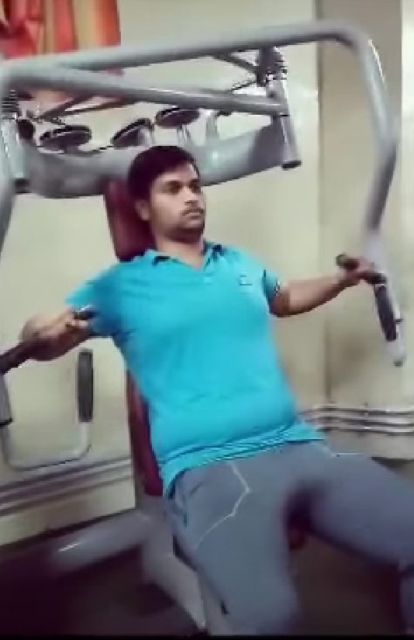**

**4. Virtual Session on our Club’s Mission and Activities :**

**Event date: 3rd November 2023**

The president and Dr.Vipin Singh, faculty coordinator of Fitness And Beyond Club provided a brief insight into the association’s mission and activities.

**Overview**

**Mission and Vision of the Club:** The session commenced with an overview of the "Fitness and Beyond" club's mission and vision, highlighting its dedication to promoting fitness, mental well-being, and holistic development among university students. The club aims to cultivate a supportive community that encourages physical activity, fosters mental well-being, and provides avenues for personal growth.

**Upcoming Activities:** Participants were informed about the club's upcoming activities, which include fitness workshops, mental health awareness campaigns, and community engagement initiatives. They were encouraged to actively participate and contribute, fostering a sense of ownership and involvement among members.

**Membership Information:** Details regarding club membership, the registration process, and the benefits of joining were shared during the session. Prospective members were provided with information on how to join the club and participate in its activities, highlighting the inclusive and supportive nature of the club's community.

**Conclusion** :The online orientation session for the "Fitness and Beyond" club provided a comprehensive overview of the club's mission, objectives, and upcoming activities. By highlighting past events, unveiling upcoming initiatives, and engaging participants in discussions, the session successfully conveyed the club's commitment to promoting fitness, mental well-being, and holistic development among university students.

**Impact and Future**: The session served as an effective platform to connect with members and prospective participants, fostering a sense of community, collaboration, and shared purpose. As the "Fitness and Beyond" club continues to grow and evolve, it remains dedicated to empowering its members to prioritize their physical and mental well-being, embrace fitness as a lifestyle, and contribute positively to the university community and beyond.

**No. of Hours Spent:** 2 hours

**Screenshots:**

**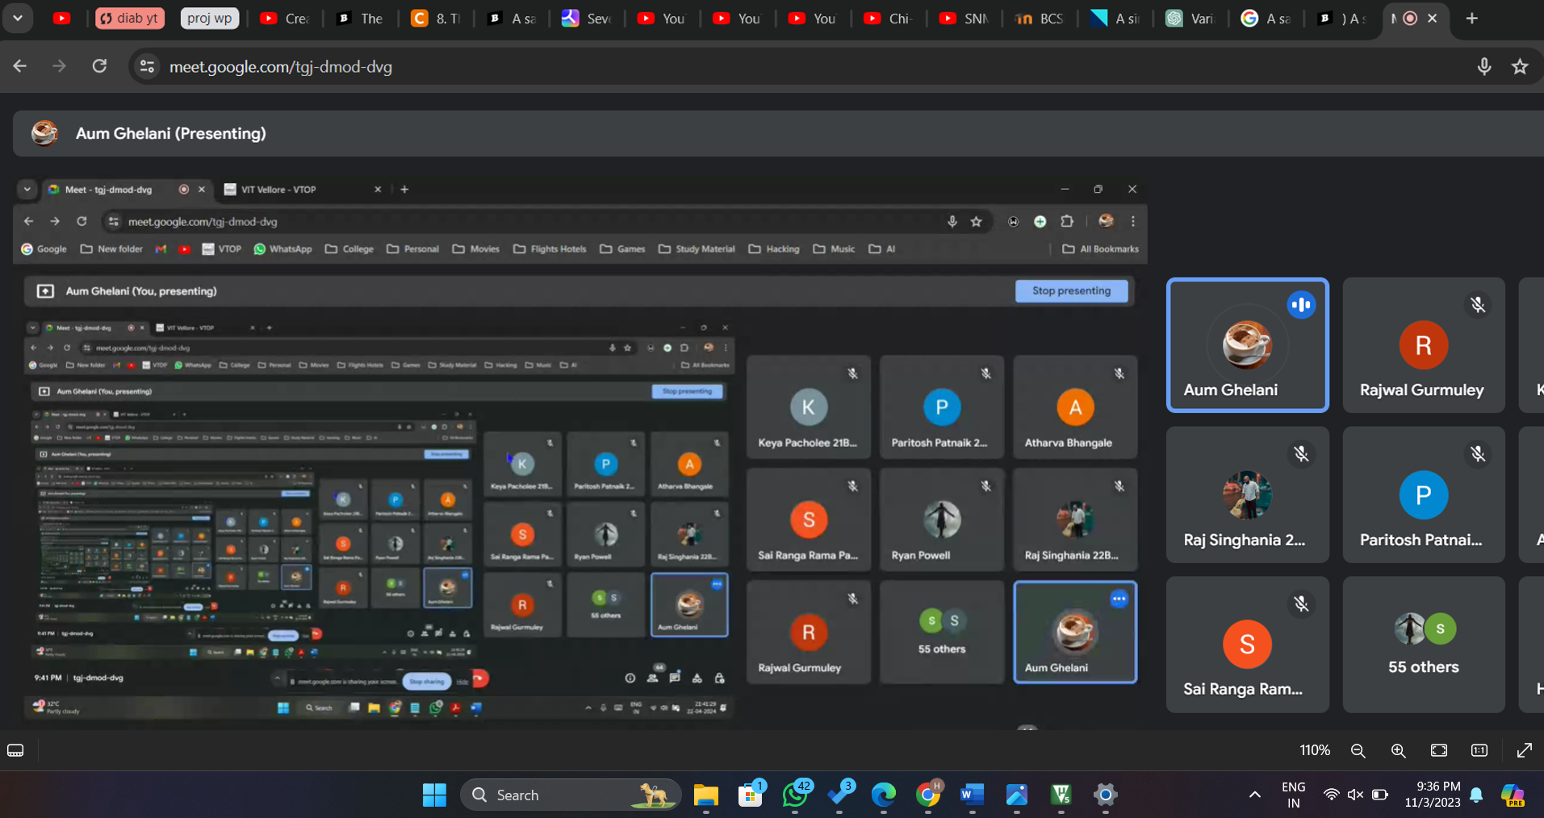**

**5. Fitness Frenzy :**

**Event date: 13th November 2023**

**Purpose and Design** The "Fitness Frenzy" quiz event was crafted to be an interactive and enjoyable session that blends entertainment with education. Participants were tasked with answering questions on health, fitness, nutrition, and mental well-being. The quiz featured a mix of multiple-choice questions, true/false statements, and scenario-based inquiries to assess participants' knowledge in these areas.

**Objectives** The primary goal of the "Fitness Frenzy" quiz event was to raise awareness and enhance understanding of health and well-being among participants. Through an engaging quiz format, the event aimed to educate participants about the significance of maintaining a healthy lifestyle, making informed decisions, and prioritizing both physical and mental well-being.

**Impact and Success** The "Fitness Frenzy" Health & Wellness Quiz event organized by the "Fitness and Beyond" club was highly successful, achieving its goals of promoting health awareness, fostering community engagement, and encouraging active participation. The event provided participants with a platform to test their knowledge, acquire new information, and connect with individuals who share a passion for health and wellness.

Top of Form

**No. of Hours Spent:** 9 hours + 6 hours (self study) = 15 hours

**Screenshots:**

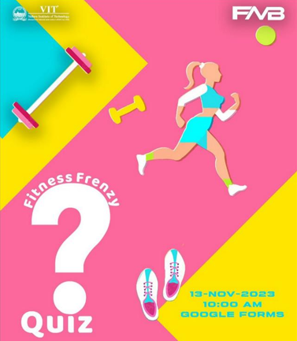

**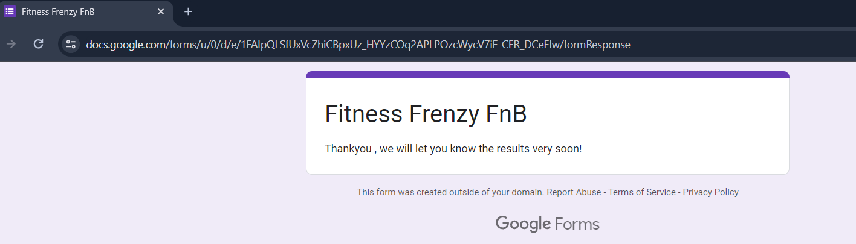**

**6. Offline Orientation :**

**Event date: 24th November 2023**

The president and Dr.Vipin Singh, faculty coordinator of Fitness And Beyond Club provided a brief insight into the association’s mission and activities.

Attending the orientation at Fitness and Beyond, I was immediately struck by the focus on the connection between physical and mental well-being. The session provided insight into the club's structure and upcoming events, and it was both engaging and enlightening. We discussed the importance of maintaining a balanced lifestyle for overall health, which was eye-opening. Learning about how exercise can transform both the body and mind was truly inspiring. I left feeling empowered and motivated to prioritize my health holistically, knowing that Fitness and Beyond is more than just about exercise—it's about fostering overall wellness. I'm excited to start this journey towards a healthier, happier me and eagerly anticipate participating in FnB's upcoming events.

The meeting commenced with a brief introduction to the "Fitness and Beyond" club, emphasizing its goal of promoting fitness, mental well-being, and holistic development among university students. The club's commitment to creating a supportive and inclusive community was highlighted, setting the tone for the meeting. The meeting included a recap of past events and activities organized by the club, such as the "Athletic Trifecta," "Mental Health Matters," and "Fitness Frenzy" quiz event. Attendees were briefed on the objectives, format, and outcomes of these events, showcasing the club's successful track record in organizing engaging and impactful initiatives for its members. Despite limited attendance with only 20 members present, the in-person orientation meeting for the "Fitness and Beyond" club was a productive and engaging session. It successfully introduced new and existing members to the club's mission, objectives, and upcoming activities, fostering a sense of community and camaraderie among attendees.

**No. of Hours Spent:** 2 hours

**Screenshots:**

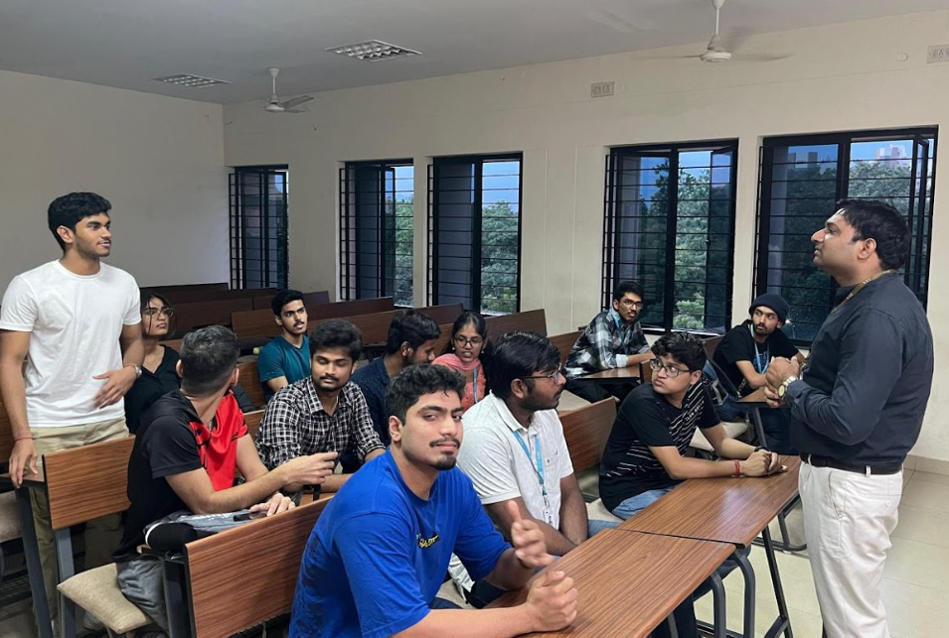

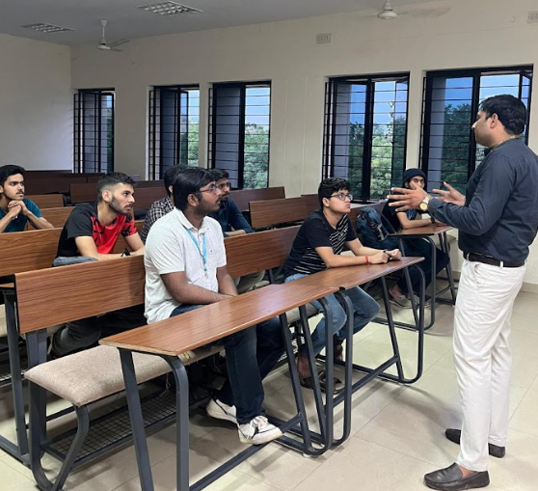

**7.Nutrition Nirvana :**

**Event date: 25th November 2023**

"Nutrition Nirvana" was an engaging quiz on the Quizizz platform, offering an in-depth exploration of healthy eating and balanced living. Each question delved into various aspects of nutrition, covering topics such as macronutrients, micronutrients, and the impact of dietary choices on well-being.

The quiz featured meticulously crafted questions that spanned a wide range of nutrition-related topics, including dietary guidelines, food groups, meal planning, and the importance of hydration. What made it stand out was its ability to test factual knowledge while also prompting critical thinking about dietary habits and their impact on health.

**No. of Hours Spent:** 8 hours + 10 hours (self study) = 18 hours

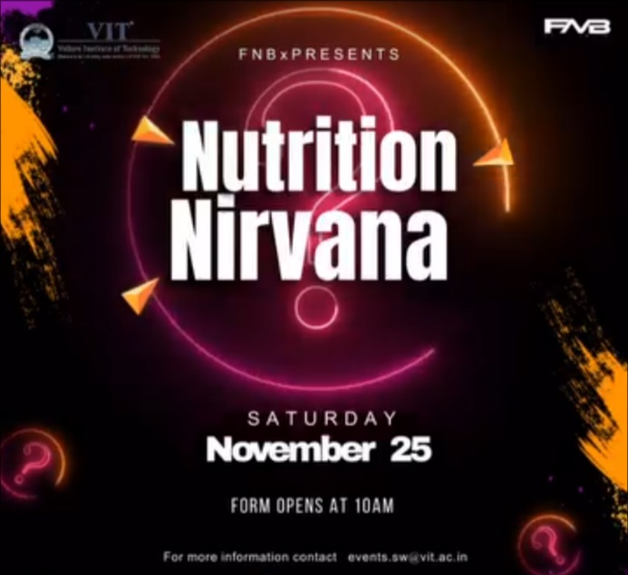**Screenshots:**

**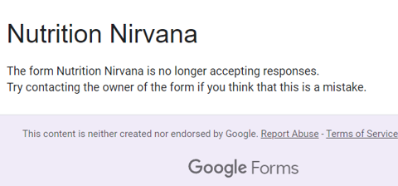**

Top of Form

**8.GYM JAMS :**

**Event date: 27th November 2023**

"Gym Jams" proved to be an invigorating quiz experience, tailored for fitness enthusiasts eager to test their knowledge about gym routines and workouts. Hosted on the Quizizz platform, this quiz offered a comprehensive exploration of various aspects related to gym culture and exercise regimens. From questions about different types of workouts to inquiries about muscle groups and proper form, "Gym Jams" covered a wide range of topics essential for anyone looking to maximize their time at the gym. What made the quiz particularly engaging was its interactive format, which allowed me to assess my understanding of gym-related concepts in a fun and dynamic way. Scoring well in "Gym Jams" was not just a measure of my knowledge but also a validation of my dedication to maintaining a healthy and active lifestyle. It reinforced the idea that fitness is not just about physical appearance but also about overall well-being and personal growth.

The "Gym Jams" event consisted of a series of multiple-choice questions, true/false statements, and scenario-based questions related to gym workouts, exercises, equipment, and fitness routines. Participants were encouraged to answer questions 15 | Page based on their knowledge and experience with gym practices, aiming to demonstrate their understanding of effective workout techniques, safety precautions, and fitness principles. The event was open to all members of the "Fitness and Beyond" club, as well as other fitness enthusiasts interested in testing their knowledge of gym-related topics. Participants had the option to compete individually or in teams, fostering a competitive yet collaborative atmosphere and encouraging active participation among attendees.

**No. of Hours Spent:** 8 hours + 6 hours (self study) = 14 hours

**Screenshots:**

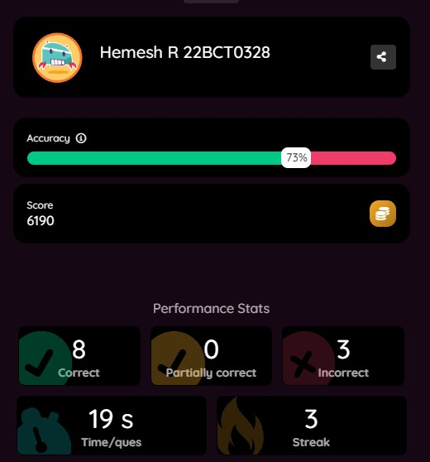

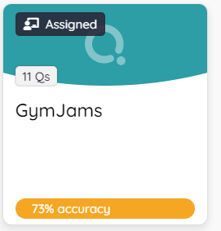

**9. Wellness Wisdom:**

**Event date: 30th November 2023**

Participating in "Wellness Wisdom" was an eye-opening journey into holistic well-being, covering essential aspects like optimum nutrition, effective training methods, and the importance of rest and recovery. Hosted on Quizizz, this quiz provided a deep dive into the interconnected elements of physical health and fitness. As I progressed through the quiz, each question prompted me to reconsider how my nutrition choices, training methods, and rest habits impact my overall well-being. From understanding the role of macronutrients in fueling workouts to exploring the benefits of incorporating flexibility exercises into my routine, "Wellness Wisdom" challenged me to think critically about my approach to fitness. Ultimately, the quiz left me feeling empowered with newfound knowledge and a deeper appreciation for the holistic nature of wellness, reinforcing the importance of balance in achieving long-term health goals.

**No. of Hours Spent:** 9 hours + 7 hours (self study) = 16 hours

**Screenshots:**

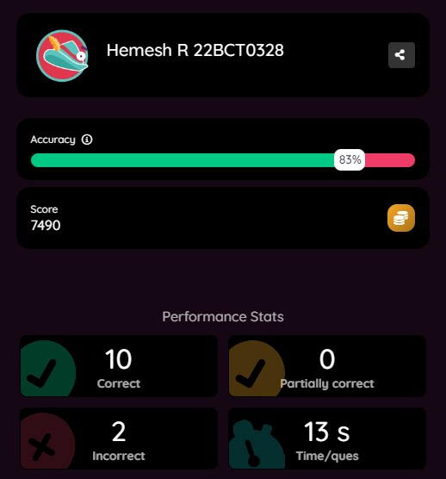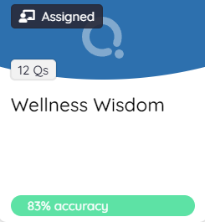

**10. VITMUN Conference Opening Ceremony:**

**Event date: 20th April 2024**

VITMUN’s opening ceremony which was organized at Channa Reddy auditorium. Our Chancellor, Mr. Vishwanathan was also there to start the ceremony with a wonderful speech. We were taught about the importance of the UN as a governing body, what its shortcomings were, and how we move forward from here as a whole. The ceremony proved to be quite inspiring and eye opening.

Mr. Praveen Chakravarty, the Chairman of the All India Professionals' Congress, is our esteemed chief guest for the event. He is also the Chairman of the Data Analytics Department of one of the Country's biggest Thinktanks. Mr. Chakravarty is also a prolific writer on India's political economy and has co-authored several articles with former Prime Minister Dr.Manmohan Singh and former Finance Minister P.Chidambaram.

Our Honorable Chancellor, Dr. G Viswanathan, will be gracing us with his presence and sharing his insights on diplomacy and polity.

**No. of Hours Spent:** 2 hours

**Screenshots:**

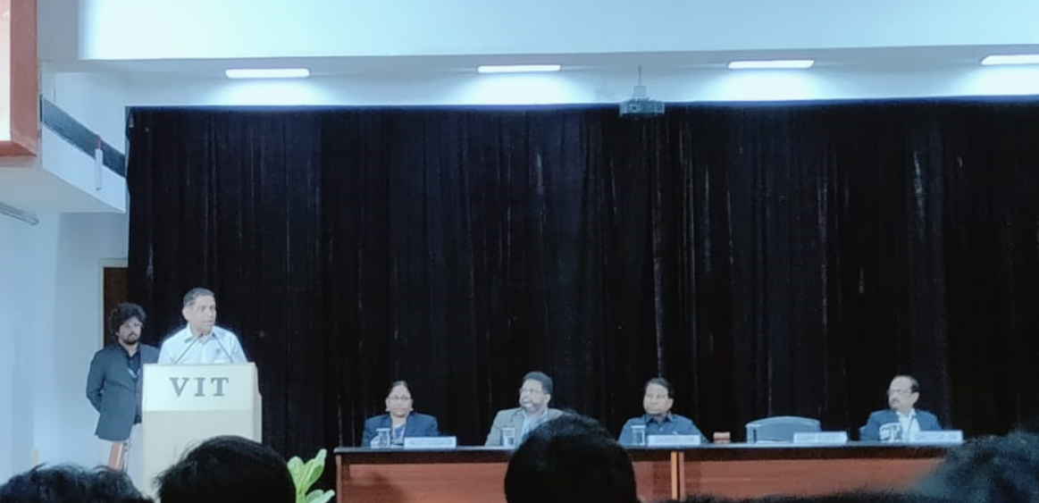

**11. Studied a book & Understood the importance of Fitness:**

**Book name:** [Peak - The New Science of Athletic Performance That is Revolutionizing Sports – 380 pages](https://www.amazon.com/dp/1603588094?tag=uuid10-20" \t "_blank)

**Date:** 10th March 2024

"Peak: The New Science of Athletic Performance That is Revolutionizing Sports" by Dr. Marc Bubbs is a comprehensive guide to optimizing athletic performance through cutting-edge science and research. The book explores various aspects of sports performance, including nutrition, training, recovery, and mindset, offering practical advice backed by scientific evidence.

In the book, Dr. Bubbs emphasizes the importance of a holistic approach to athletic performance, highlighting the interconnectedness of nutrition, training, and mindset. He discusses the latest research on topics such as macronutrient ratios, micronutrient intake, and meal timing, providing athletes with strategies to fuel their bodies for optimal performance.

Furthermore, Dr. Bubbs delves into the science behind effective training methods, emphasizing the importance of periodization, recovery, and rest. He also explores the role of mindset in athletic success, discussing techniques to enhance mental resilience and focus.

Throughout the book, Dr. Bubbs provides real-world examples and case studies from elite athletes, illustrating how the principles outlined in the book can be applied in practice. He also offers practical tips and strategies that athletes can implement to improve their performance.

Overall, "Peak" is a valuable resource for athletes, coaches, and sports enthusiasts looking to enhance their understanding of athletic performance and apply the latest scientific principles to achieve peak performance.

**No. of Hours Spent:** 5 hours

**Screenshots:** Top of Form

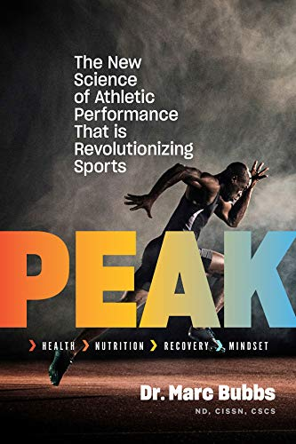

**12. Report Making Time:**

All of the images and experiences were consolidated and were made into this report following a standardized template. Each section was carefully crafted to provide a comprehensive overview of the proceedings. The report aimed to encapsulate the energy and excitement felt throughout my time with this club. The report maintains consistency and clarity, making it easy for readers to navigate and comprehend. As I say goodbye to the club, I'm filled with gratitude for the memories and friendships we've shared. I express my gratitude to Dr. Vipin Singh for the chance to take part in this EXC.

**No. of Hours Spent:** 4 hours

**FNB Riviera expo:**

At the Riviera Expo, Fitness and Beyond proudly displayed their powerlifting and tug of war events. With my friends, we entered the venue to find a lively atmosphere full of anticipation. As we explored, we witnessed impressive displays of strength and endurance, from powerlifters showcasing their skills to teams battling it out in tug of war. It was a fun experience, filled with excitement and friendly competition, leaving us feeling inspired by the athletes' performances.

**Screenshots:** Top of Form

